Data analytics solutions often include a requirement to ingest and process streams of data. Stream processing differs from batch processing in that streams are generally boundless - in other words they are continuous sources of data that must be processed perpetually rather than at fixed intervals.

Azure Stream Analytics provides a cloud service that you can use to define a query that operates on a stream of data from a streaming source, such as Azure Event Hubs or an Azure IoT Hub. You can use an Azure Stream Analytics query to ingest the stream of data directly into a data store for further analysis, or to filter, aggregate, and summarize the data based on temporal windows.

In this exercise, you’ll use Azure Stream Analytics to process a stream of sales order data, such as might be generated from an online retail application. The order data will be sent to Azure Event Hubs, from where your Azure Stream Analytics jobs will read the data and ingest it into Azure Synapse Analytics.

This exercise should take approximately ****45**** minutes to complete.

## Before you start

You’ll need an [Azure subscription](https://azure.microsoft.com/free) in which you have administrative-level access.

## Provision Azure resources

1. In the PowerShell pane, enter the following commands to clone the repo containing this exercise:

rm -r dp-203 -f

git clone https://github.com/MicrosoftLearning/dp-203-azure-data-engineer dp-203

1. After the repo has been cloned, enter the following commands to change to the folder for this exercise and run the ****setup.ps1**** script it contains:

cd dp-203/Allfiles/labs/18

./setup.ps1

## Ingest streaming data into a dedicated SQL pool

Let’s start by ingesting a stream of data directly into a table in an Azure Synapse Analytics dedicated SQL pool.

### View the streaming source and database table

1. When the setup script has finished running, minimize the cloud shell pane (you’ll return to it later). Then in the Azure portal, go to the ****dp203-**xxxxxxx** resource group that it created, and notice that this resource group contains an Azure Synapse workspace, a Storage account for your data lake, a Dedicated SQL pool, and an Event Hubs namespace.

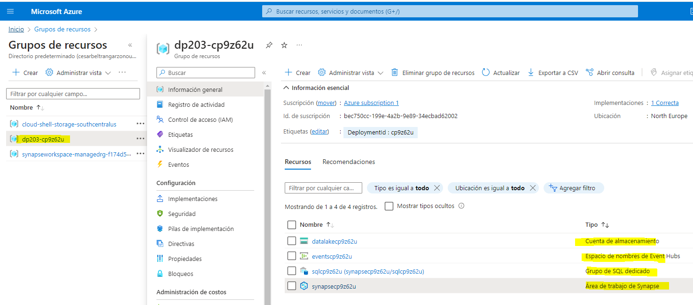

1. Select your Synapse workspace, and in its ****Overview**** page, in the ****Open Synapse Studio**** card, select ****Open**** to open Synapse Studio in a new browser tab. Synapse Studio is a web-based interface that you can use to work with your Synapse Analytics workspace.
2. On the left side of Synapse Studio, use the ****››**** icon to expand the menu - this reveals the different pages within Synapse Studio that you’ll use to manage resources and perform data analytics tasks.
3. On the ****Manage**** page, in the ****SQL pools**** section, select the ****sql**xxxxxxx** dedicated SQL pool row and then use its ****▷**** icon to resume it.

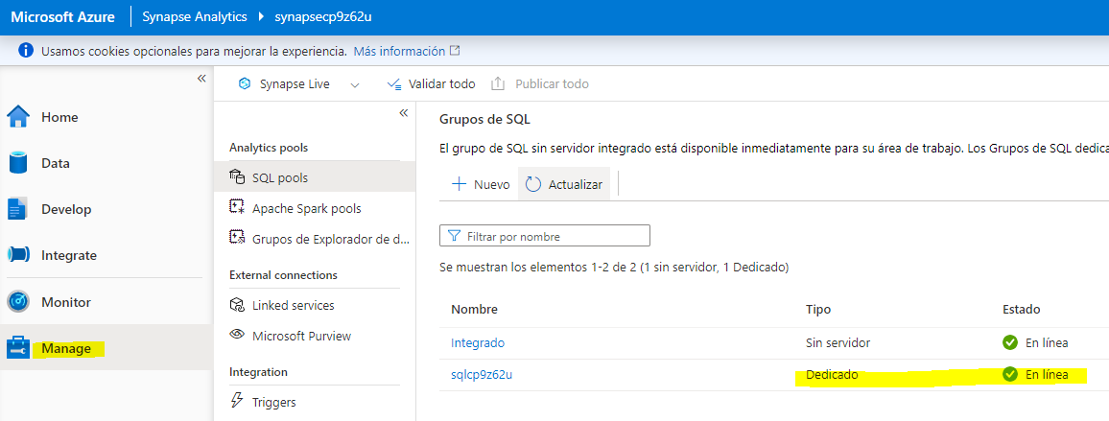

1. While you wait for the SQL pool to start, switch back to the browser tab containing the Azure portal and re-open the cloud shell pane.
2. In the cloud shell pane, enter the following command to run a client app that sends 100 simulated orders to Azure Event Hubs:

node ~/dp-203/Allfiles/labs/18/orderclient

1. Observe the order data as it is sent - each order consists of a product ID and a quantity.

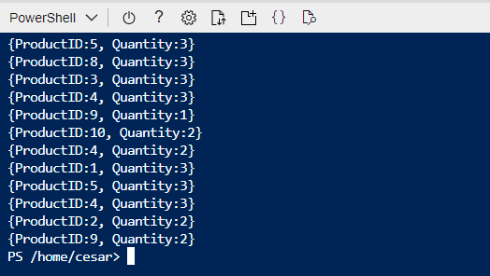

1. After the order client app has finished, minimize the cloud shell pane and switch back to the Synapse Studio browser tab.
2. In Synapse Studio, on the ****Manage**** page, ensure that your dedicated SQL pool has a status of ****Online****, then switch to the ****data**** page and in the ****Workspace**** pane, expand ****SQL database****, your ****sql**xxxxxxx** SQL pool, and ****Tables**** to see the ****dbo.FactOrder**** table.

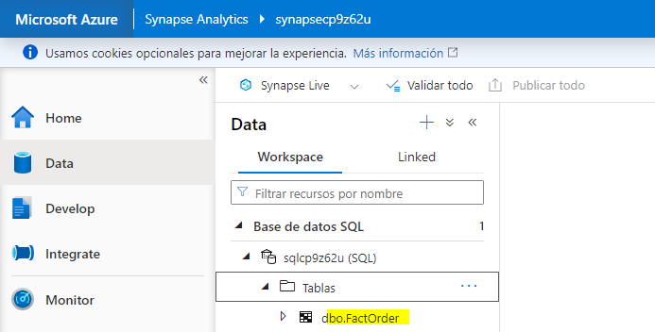

1. In the ****…**** menu for the ****dbo.FactOrder**** table, select ****New SQL script**** > ****Select TOP 100 rows**** and review the results. Observe that the table includes columns for ****OrderDateTime****, ****ProductID****, and ****Quantity**** but there are currently no rows of data.

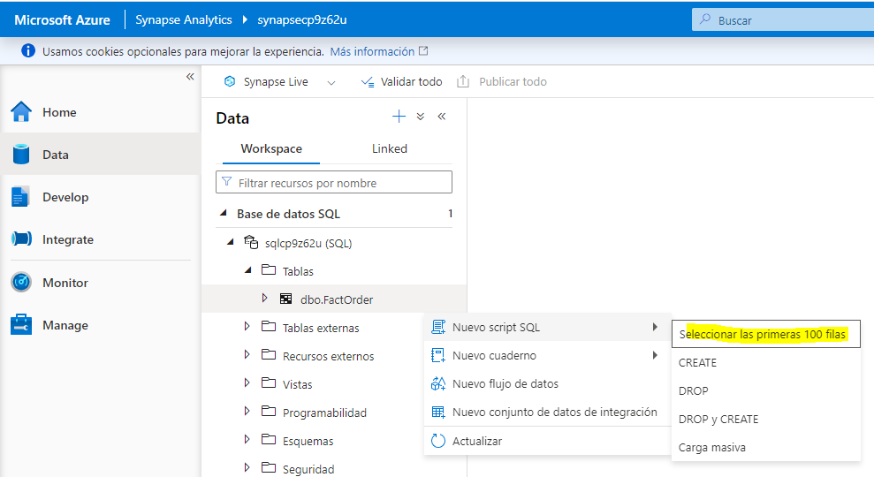

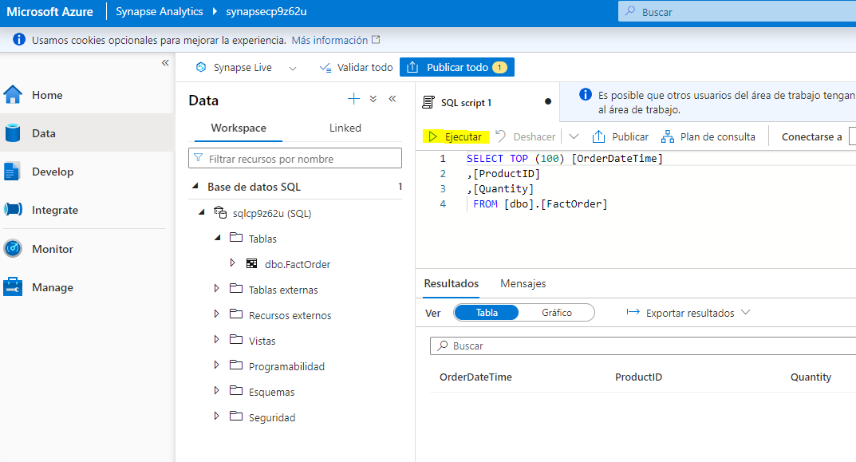

### Create an Azure Stream Analytics job to ingest order data

1. Switch back to the browser tab containing the Azure portal, and note the region where your ****dp203-**xxxxxxx** resource group was provisioned - you will create your Stream Analytics job in the same region.

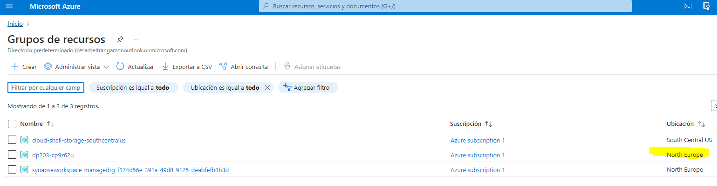

1. On the ****Home**** page select ****+ Create a resource**** and search for Stream Analytics job. Then create a ****Stream Analytics job**** with the following properties:

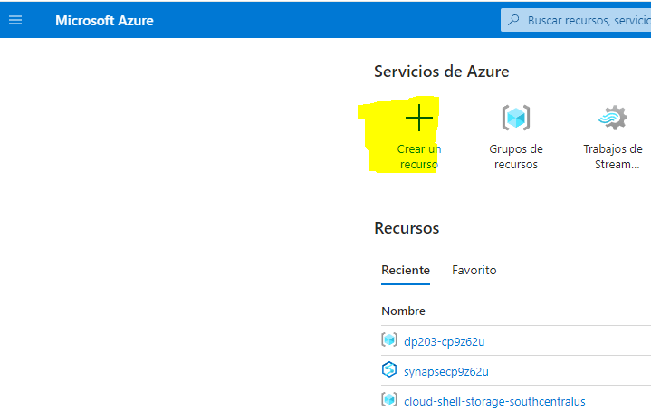

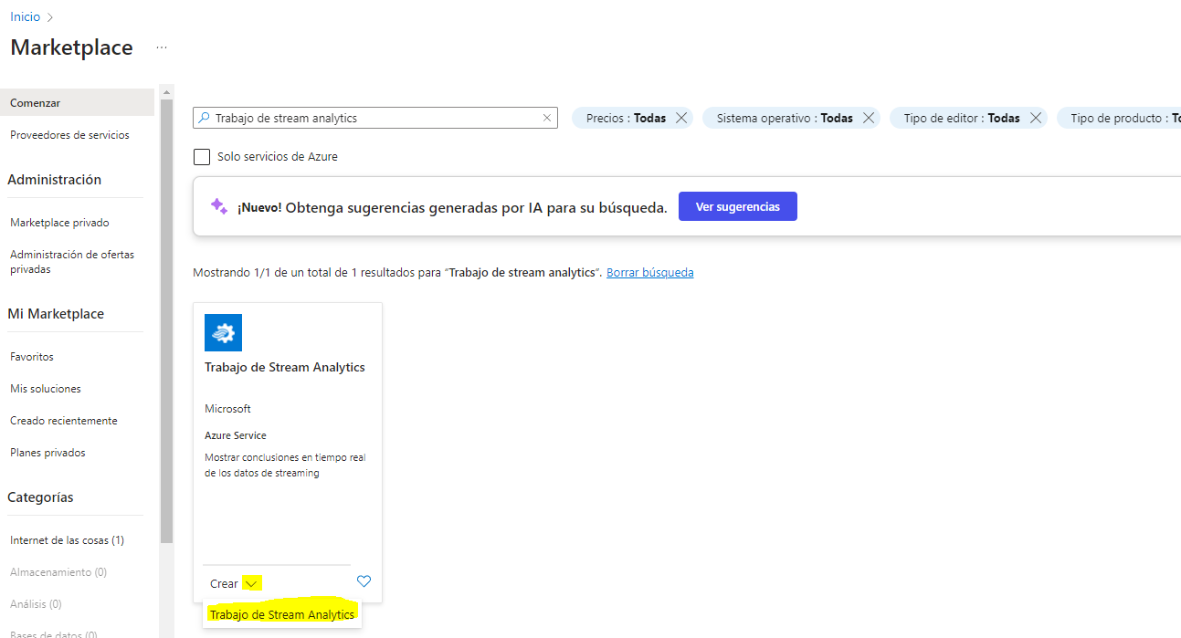

* ****Basics****:
* ****Subscription****: Your Azure subscription
* ****Resource group****: Select the existing ****dp203-**xxxxxxx** resource group.
* ****Name****: ingest-orders
* ****Region****: Select the same region where your Synapse Analytics workspace is provisioned.
* ****Hosting environment****: Cloud
* ****Streaming units****: 1
* ****Storage****:
* ****Add storage account****: Selected
* ****Subscription****: Your Azure subscription
* ****Storage accounts****: Select the ****datalake**xxxxxxx** storage account
* ****Authentication mode****: Connection string
* ****Secure private data in storage account****: Selected
* ****Tags****:
* None

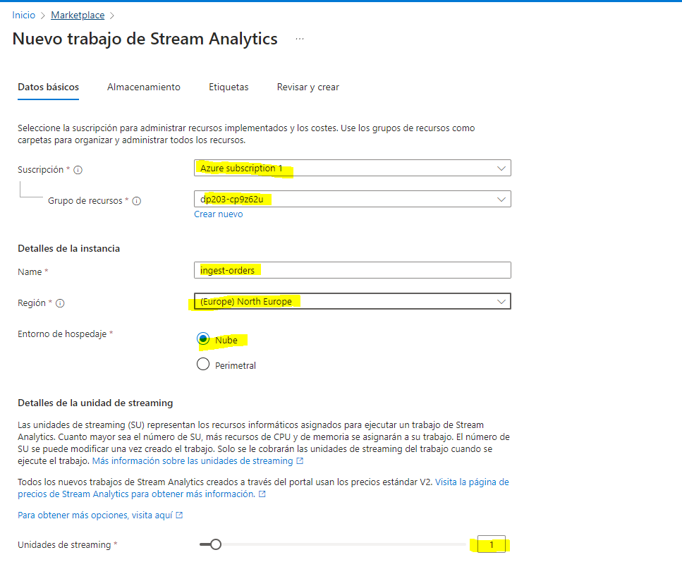

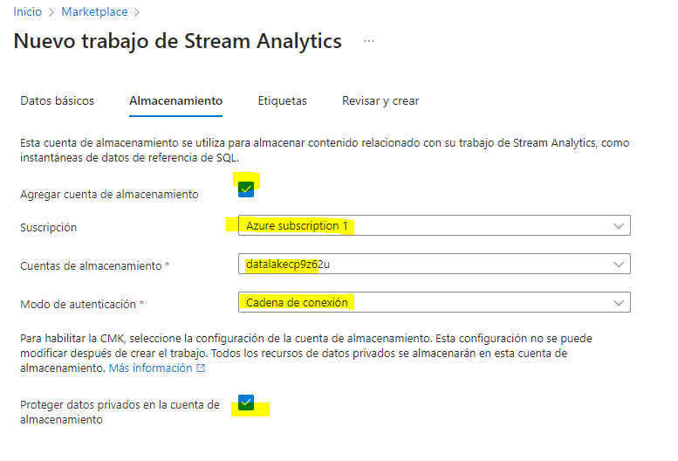

1. Wait for deployment to complete and then go to the deployed Stream Analytics job resource.

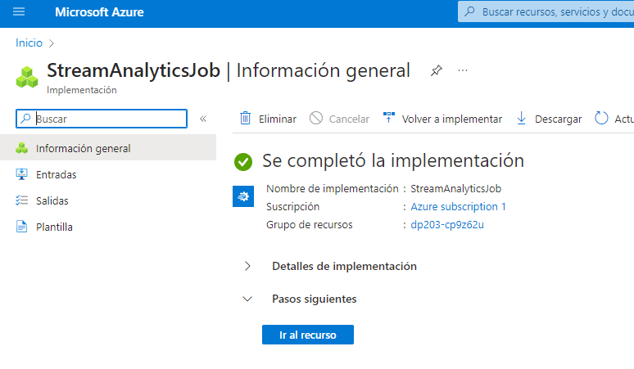

### Create an input for the event data stream

1. On the ****ingest-orders**** overview page, select the ****Inputs**** page. Use the ****Add input**** menu to add an ****Event Hub**** input with the following properties:

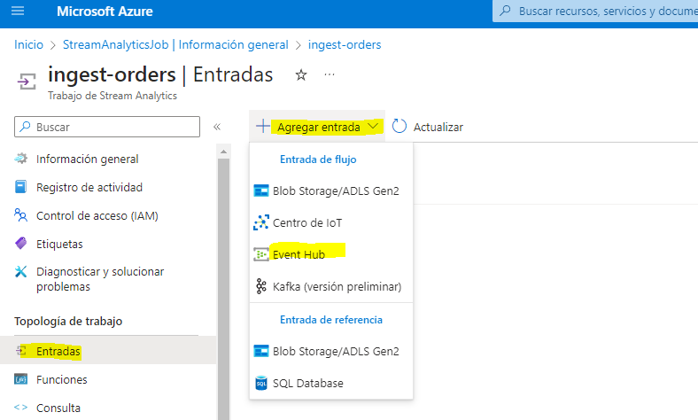

* ****Input alias****: orders
* ****Select Event Hub from your subscriptions****: Selected
* ****Subscription****: Your Azure subscription
* ****Event Hub namespace****: Select the ****events**xxxxxxx** Event Hubs namespace
* ****Event Hub name****: Select the existing ****eventhub**xxxxxxx** event hub.
* ****Event Hub consumer group****: Select the ****Use existing**** then select the ****$Default**** consumer group
* ****Authentication mode****: Create system assigned managed identity
* ****Partition key****: Leave blank
* ****Event serialization format****: JSON
* ****Encoding****: UTF-8

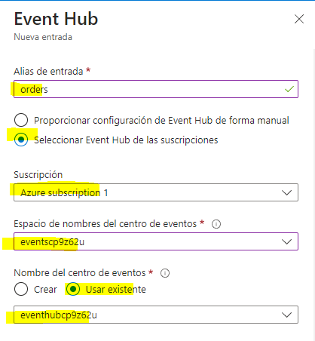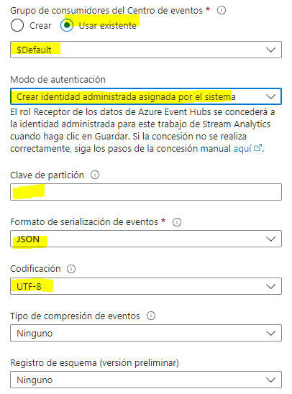

1. Save the input and wait while it is created. You will see several notifications. Wait for a ****Successful connection test**** notification.

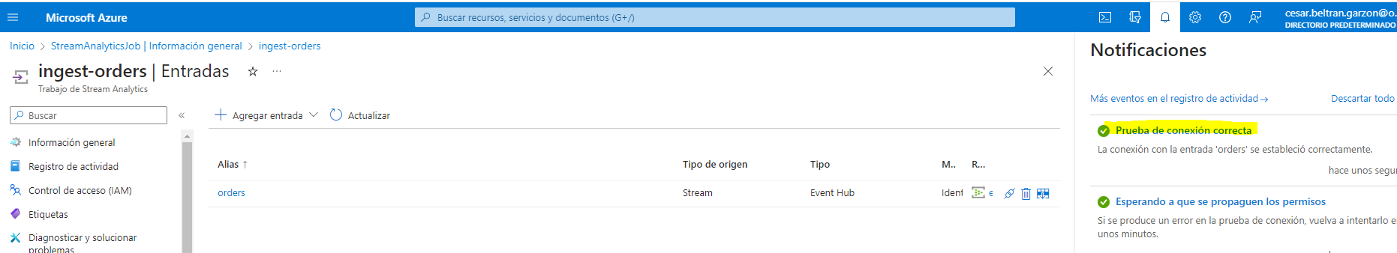

### Create an output for the SQL table

1. View the ****Outputs**** page for the ****ingest-orders**** Stream Analytics job. Then use the ****Add output**** menu to add an ****Azure Synapse Analytics**** output with the following properties:

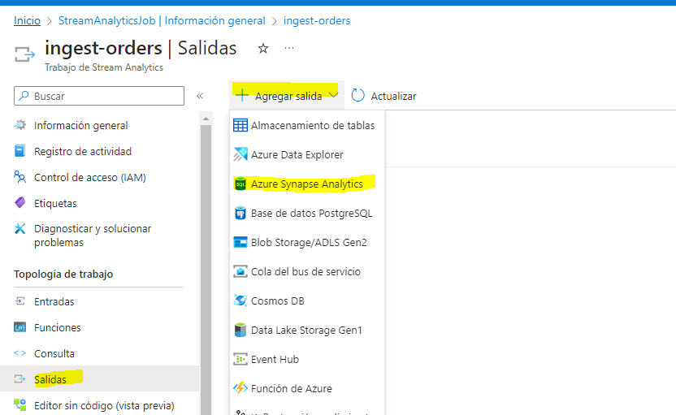

* ****Output alias****: FactOrder
* ****Select Azure Synapse Analytics from your subscriptions****: Selected
* ****Subscription****: Your Azure subscription
* ****Database****: Select the ****sql**xxxxxxx**(synapse**xxxxxxx**)**** database
* ****Authentication mode****: SQL server authentication
* ****Username****: SQLUser
* ****Password****: The password you specified for your SQL Pool when running the setup script
* ****Table****: FactOrder

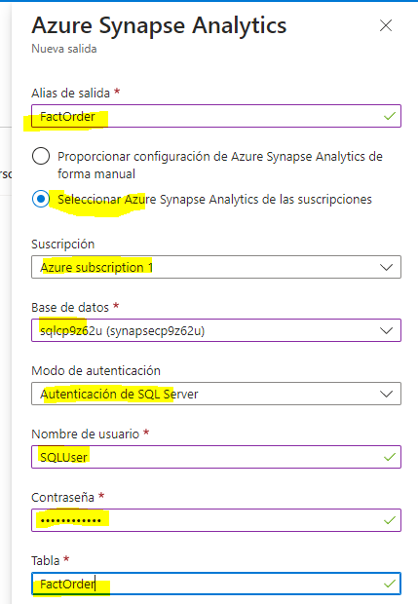

1. Save the output and wait while it is created. You will see several notifications. Wait for a ****Successful connection test**** notification.

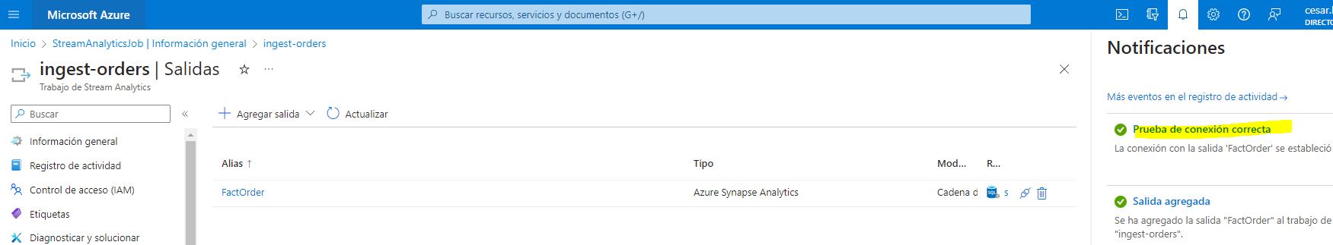

### Create a query to ingest the event stream

1. View the ****Query**** page for the ****ingest-orders**** Stream Analytics job. Then wait a few moments until the input preview is displayed (based on the sales order events previously captured in the event hub).
2. Observe that the input data includes the ****ProductID**** and ****Quantity**** fields in the messages submitted by the client app, as well as additional Event Hubs fields - including the ****EventProcessedUtcTime**** field that indicates when the event was added to the event hub.

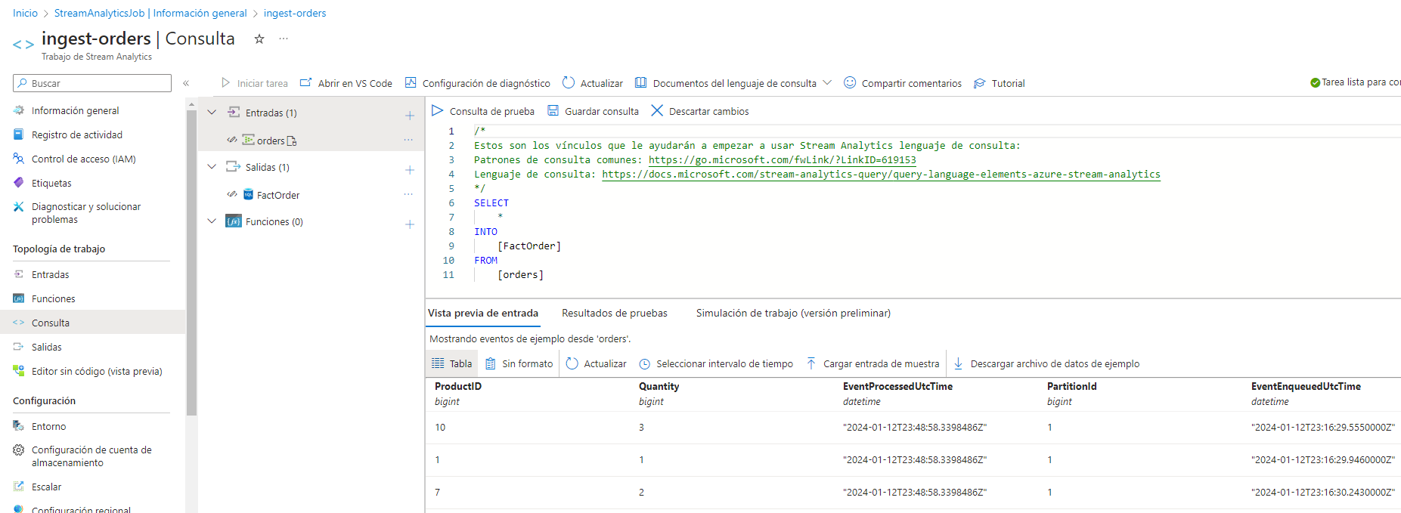

1. Modify the default query as follows:

SELECT

EventProcessedUtcTime AS OrderDateTime,

ProductID,

Quantity

INTO

[FactOrder]

FROM

[orders]

Observe that this query takes fields from the input (event hub) and writes them directly to the output (SQL table).

1. Save the query.

### Run the streaming job to ingest order data

1. View the ****Overview**** page for the ****ingest-orders**** Stream Analytics job, and on the ****Properties**** tab review the ****Inputs****, ****Query****, ****Outputs****, and ****Functions**** for the job. If the number of ****Inputs**** and ****Outputs**** is 0, use the ****↻ Refresh**** button on the ****Overview**** page to display the ****orders**** input and ****FactTable**** output.
2. Select the ****▷ Start**** button, and start the streaming job now. Wait until you are notified that the streaming job started successfully.

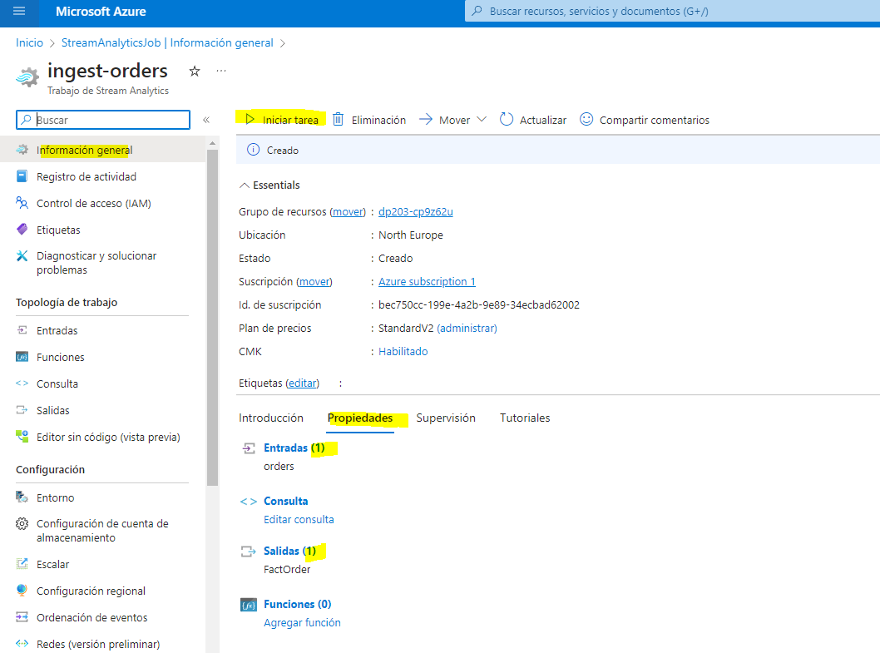

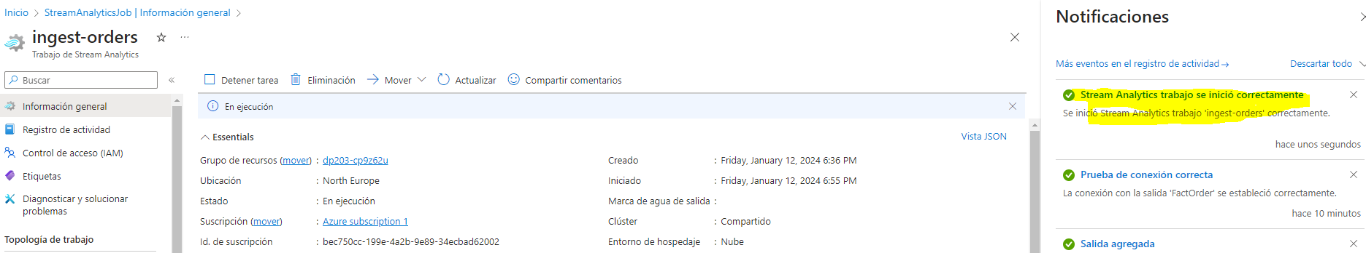

1. Re-open the cloud shell pane and re-run the following command to submit another 100 orders.

node ~/dp-203/Allfiles/labs/18/orderclient

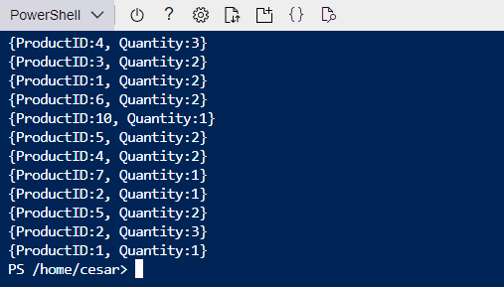

1. While the order client app is running, switch to the Synapse Studio browser tab and view the query you previously ran to select the TOP 100 rows from the ****dbo.FactOrder**** table.
2. Use the ****▷ Run**** button to re-run the query and verify that the table now contains order data from the event stream (if not, wait a minute and re-run the query again). The Stream Analytics job will push all new event data into the table as long as the job is running and order events are being sent to the event hub.
3. On the ****Manage**** page, pause the ****sql**xxxxxxx** dedicated SQL pool (to prevent unnecessary Azure charges).

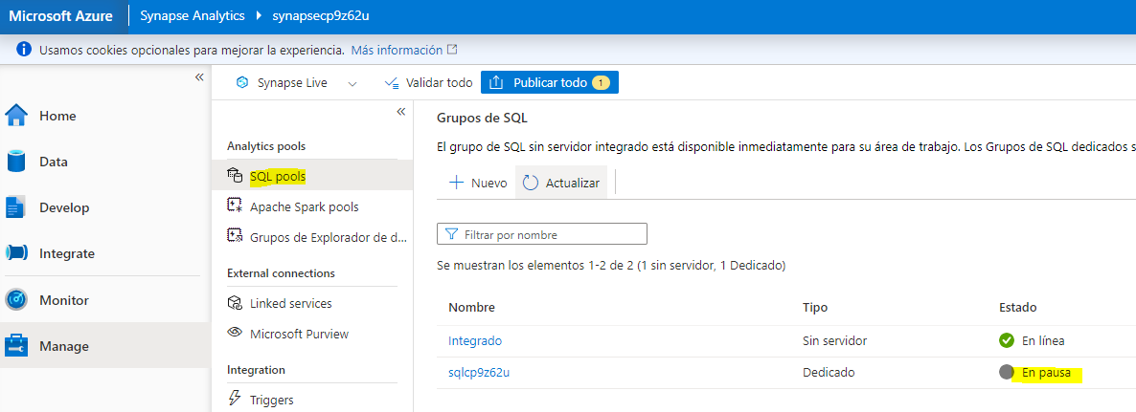

1. Return to the browser tab containing the Azure Portal and minimize the cloud shell pane. Then use the ****🗆 Stop**** button to stop the Stream Analytics job and wait for the notification that the Stream Analytics job has stopped successfully.

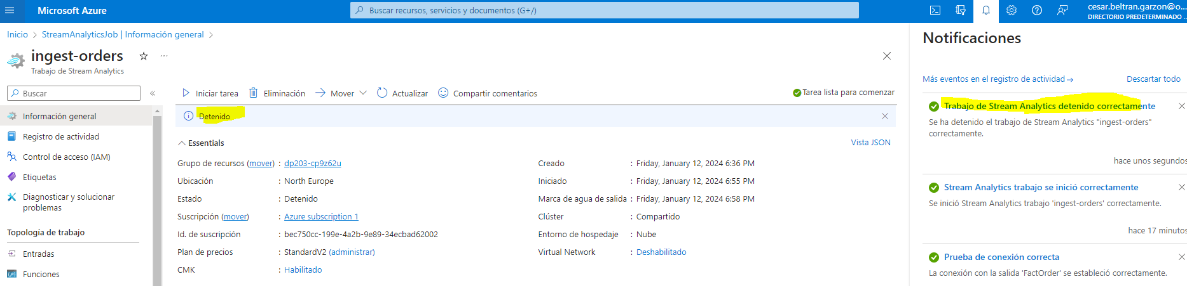

## Summarize streaming data in a data lake

So far, you’ve seen how to use a Stream Analytics job to ingest messages from a streaming source into a SQL table. Now let’s explore how to use Azure Stream Analytics to aggregate data over temporal windows - in this case, to calculate the total quantity of each product sold every 5 seconds. We’ll also explore how to use a different kind of output for the job by writing the results in CSV format in a data lake blob store.

### Create an Azure Stream Analytics job to aggregate order data

1. In the Azure portal, on the ****Home**** page select ****+ Create a resource**** and search for Stream Analytics job. Then create a ****Stream Analytics job**** with the following properties:

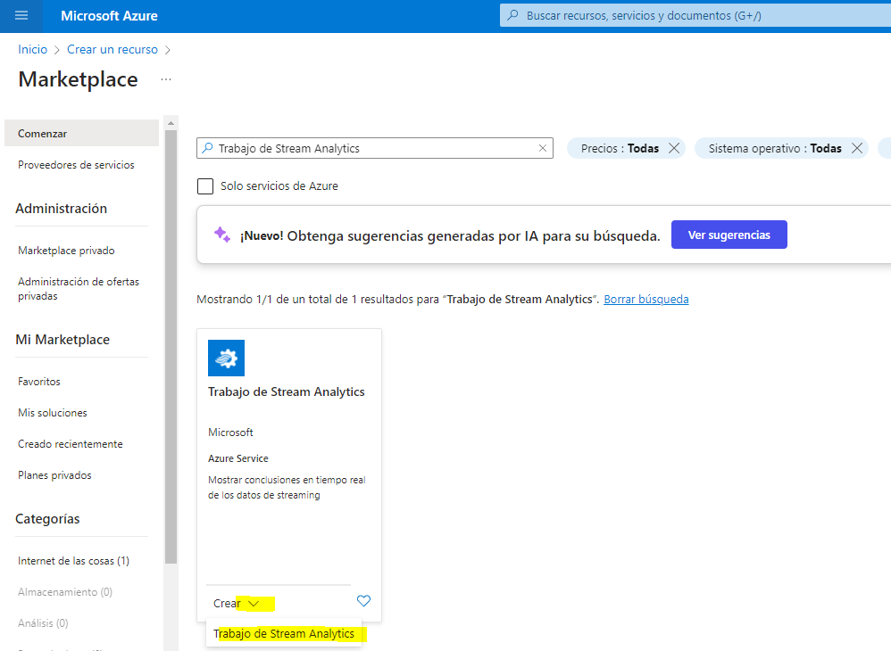

* ****Basics****:
  + ****Subscription****: Your Azure subscription
  + ****Resource group****: Select the existing ****dp203-**xxxxxxx** resource group.
  + ****Name****: aggregate-orders
  + ****Region****: Select the same region where your Synapse Analytics workspace is provisioned.
  + ****Hosting environment****: Cloud
  + ****Streaming units****: 1
* ****Storage****:
  + ****Add storage account****: Selected
  + ****Subscription****: Your Azure subscription
  + ****Storage accounts****: Select the ****datalake**xxxxxxx** storage account
  + ****Authentication mode****: Connection string
  + ****Secure private data in storage account****: Selected
* ****Tags****:
  + None

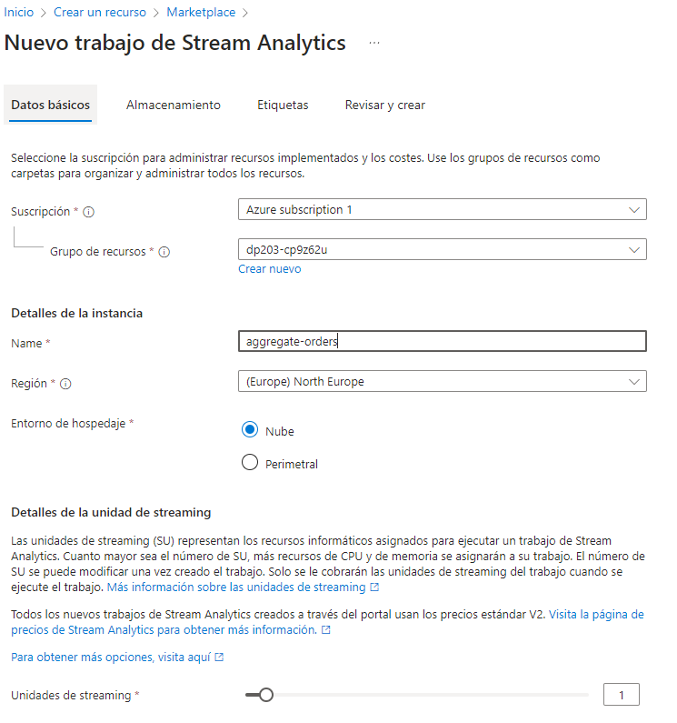

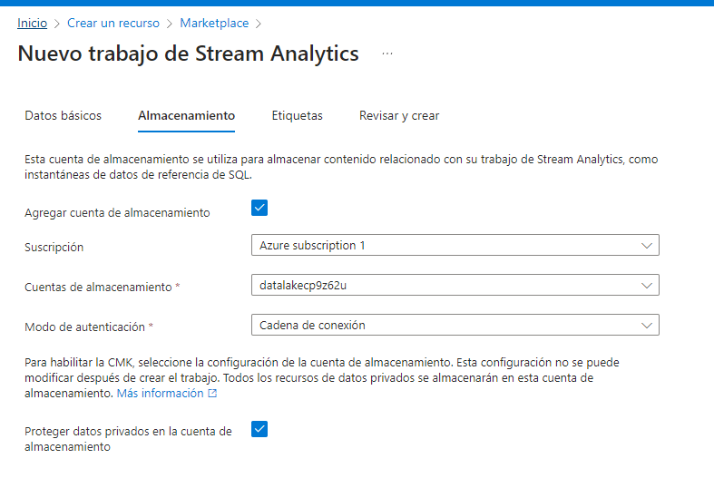

1. Wait for deployment to complete and then go to the deployed Stream Analytics job resource.

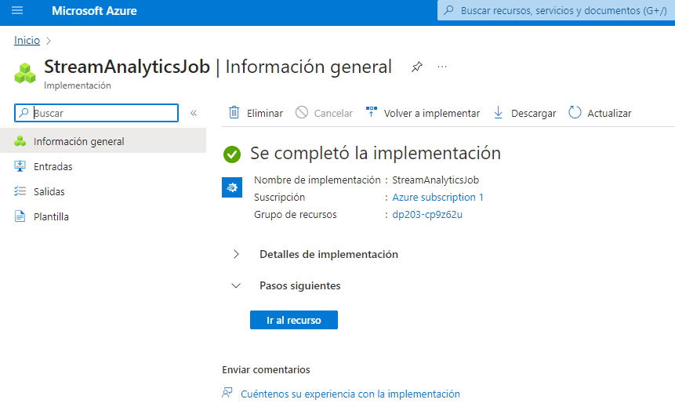

### Create an input for the raw order data

1. On the ****aggregate-orders**** overview page, select the ****Inputs**** page. Use the ****Add input**** menu to add an ****Event Hub**** input with the following properties:

* ****Input alias****: orders
* ****Select Event Hub from your subscriptions****: Selected
* ****Subscription****: Your Azure subscription
* ****Event Hub namespace****: Select the ****events**xxxxxxx** Event Hubs namespace
* ****Event Hub name****: Select the existing ****eventhub**xxxxxxx** event hub.
* ****Event Hub consumer group****: Select the existing ****$Default**** consumer group
* ****Authentication mode****: Create system assigned managed identity
* ****Partition key****: Leave blank
* ****Event serialization format****: JSON
* ****Encoding****: UTF-8

1. Save the input and wait while it is created. You will see several notifications. Wait for a ****Successful connection test**** notification.

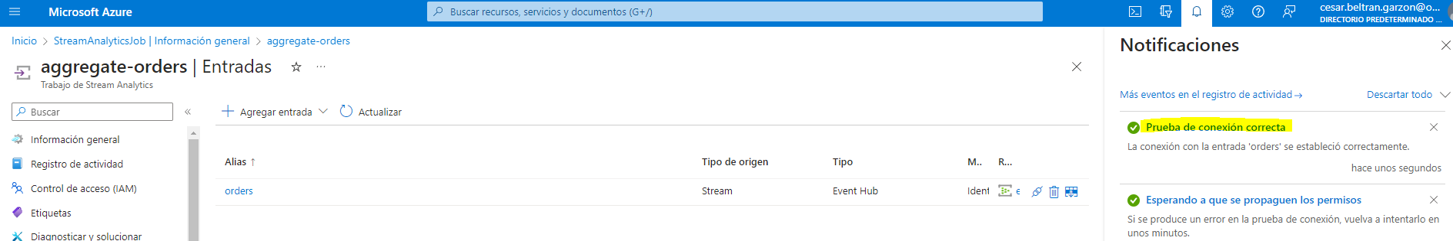

### Create an output for the data lake store

1. View the ****Outputs**** page for the ****aggregate-orders**** Stream Analytics job. Then use the ****Add output**** menu to add a ****Blob storage/ADLS Gen2**** output with the following properties:

* ****Output alias****: datalake
* ****Select Select Blob storage/ADLS Gen2 from your subscriptions from your subscriptions****: Selected
* ****Subscription****: Your Azure subscription
* ****Storage account****: Select the ****datalake**xxxxxxx** storage account
* ****Container****: Select ****Use existing****, and from the list select the ****files**** container
* ****Authentication mode****: Connection string
* ****Event serialization format****: CSV - Comma (,)
* ****Encoding****: UTF-8
* ****Write mode****: Append,as results arrive
* ****Path pattern****: {date}
* ****Date format****: YYYY/MM/DD
* ****Time format****: Not applicable
* ****Minimum rows****: 20
* ****Maximum time****: 0 Hours, 1 minutes, 0 seconds

1. Save the output and wait while it is created. You will see several notifications. Wait for a ****Successful connection test**** notification.

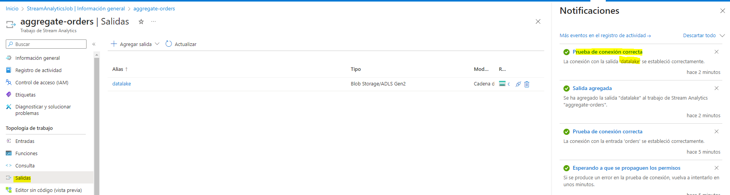

### Create a query to aggregate the event data

1. View the ****Query**** page for the ****aggregate-orders**** Stream Analytics job.
2. Modify the default query as follows:

SELECT

DateAdd(second,-5,System.TimeStamp) AS StartTime,

System.TimeStamp AS EndTime,

ProductID,

SUM(Quantity) AS Orders

INTO

[datalake]

FROM

[orders] TIMESTAMP BY EventProcessedUtcTime

GROUP BY ProductID, TumblingWindow(second, 5)

HAVING COUNT(*) > 1

Observe that this query uses the ****System.Timestamp**** (based on the ****EventProcessedUtcTime**** field) to define the start and end of each 5 second tumbling (non-overlapping sequential) window in which the total quantity for each product ID is calculated.

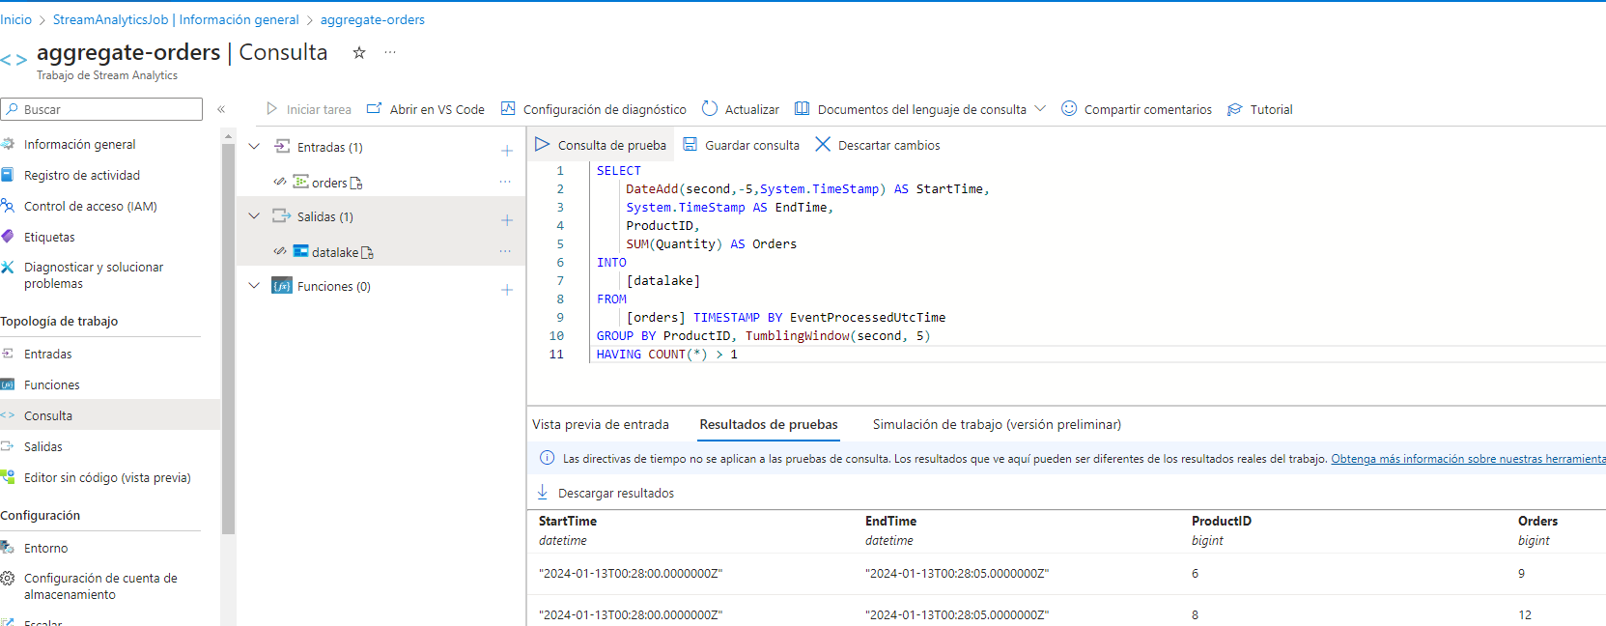

1. Save the query.

### Run the streaming job to aggregate order data

1. View the ****Overview**** page for the ****aggregate-orders**** Stream Analytics job, and on the ****Properties**** tab review the ****Inputs****, ****Query****, ****Outputs****, and ****Functions**** for the job. If the number of ****Inputs**** and ****Outputs**** is 0, use the ****↻ Refresh**** button on the ****Overview**** page to display the ****orders**** input and ****datalake**** output.
2. Select the ****▷ Start**** button, and start the streaming job now. Wait until you are notified that the streaming job started successfully.

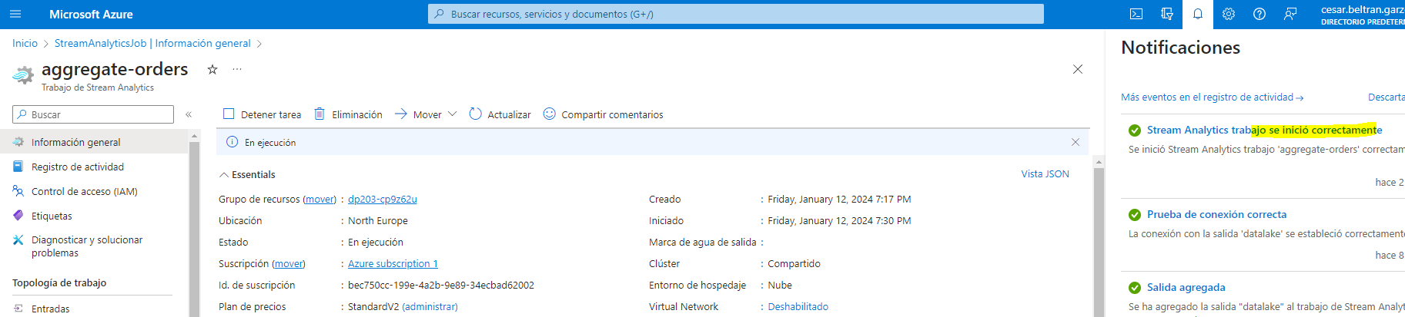

1. Re-open the cloud shell pane and re-run the following command to submit another 100 orders:

node ~/dp-203/Allfiles/labs/18/orderclient

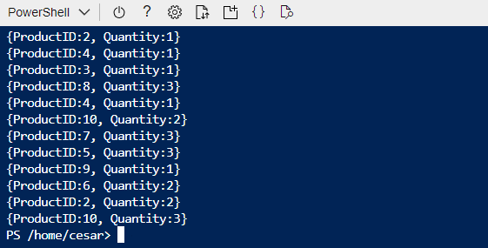

1. When the order app has finished, minimize the cloud shell pane. Then switch to the Synapse Studio browser tab and on the ****Data**** page, on the ****Linked**** tab, expand ****Azure Data Lake Storage Gen2**** > ****synapse**xxxxxxx**(primary - datalake**xxxxxxx**)**** and select the ****files (Primary)**** container.

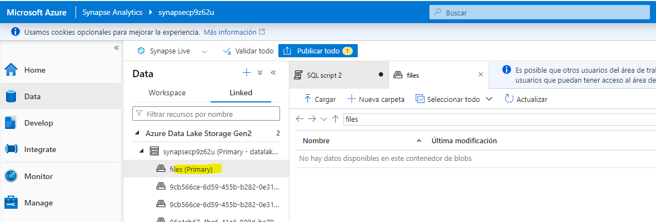

1. If the ****files**** container is empty, wait a minute or so and then use the ****↻ Refresh**** to refresh the view. Eventually, a folder named for the current year should be displayed. This in turn contains folders for the month and day.
2. Select the folder for the year and on the ****New SQL script**** menu, select ****Select TOP 100 rows****. Then set the ****File type**** to ****Text format**** and apply the settings.

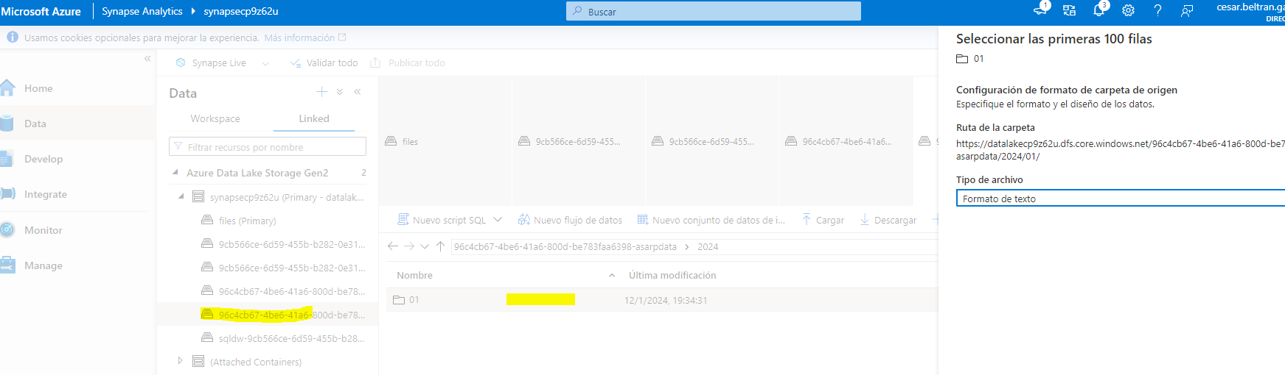

1. In the query pane that opens, modify the query to add a HEADER_ROW = TRUE parameter as shown here:

SELECT

TOP 100 *

FROM

OPENROWSET(

BULK 'https://datalakexxxxxxx.dfs.core.windows.net/files/2023/**',

FORMAT = 'CSV',

PARSER_VERSION = '2.0',

HEADER_ROW = TRUE

) AS [result]

1. Use the ****▷ Run**** button to run the SQL query and view the results, which show the quantity of each product ordered in five-second periods.
2. Return to the browser tab containing the Azure Portal and use the ****🗆 Stop**** button to stop the Stream Analytics job and wait for the notification that the Stream Analytics job has stopped successfully.

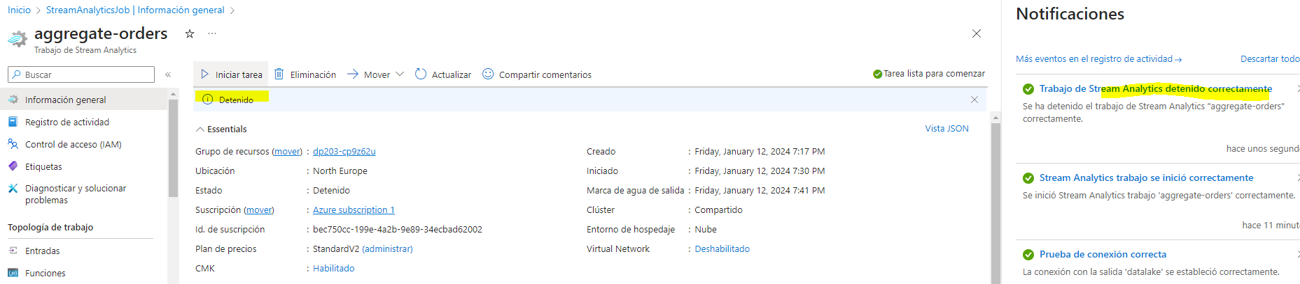

## Delete Azure resources

If you’ve finished exploring Azure Stream Analytics, you should delete the resources you’ve created to avoid unnecessary Azure costs.

1. Close the Azure Synapse Studio browser tab and return to the Azure portal.
2. On the Azure portal, on the ****Home**** page, select ****Resource groups****.
3. Select the ****dp203-**xxxxxxx** resource group containing your Azure Synapse, Event Hubs, and Stream Analytics resources (not the managed resource group).
4. At the top of the ****Overview**** page for your resource group, select ****Delete resource group****.
5. Enter the ****dp203-**xxxxxxx** resource group name to confirm you want to delete it, and select ****Delete****.

After a few minutes, the resources created in this exercise will be deleted.